There are two types of system available in [electric circuit](https://www.electrical4u.com/electric-circuit-and-electrical-circuit-element/), single phase and **three phase system**. In single phase circuit, there will be only one phase, i.e the [current](https://www.electrical4u.com/electric-current-and-theory-of-electricity/) will flow through only one wire and there will be one return path called neutral line to complete the circuit. So in single phase minimum amount of power can be transported. Here the generating station and load station will also be single phase. This is an old system using from previous time.  
In 1882, new invention has been done on polyphase system, that more than one phase can be used for generating, transmitting and for load system. **Three phase circuit** is the polyphase system where three phases are send together from the generator to the load.

Each phase are having a phase difference of 120o, i.e 120o angle electrically. So from the total of 360o, three phases are equally divided into 120o each. The power in **three phase system** is continuous as all the three phases are involved in generating the total power. The sinusoidal waves for 3 phase system is shown below-  
The three phases can be used as single phase each. So if the load is single phase, then one phase can be taken from the **three phase circuit** and the neutral can be used as ground to complete the circuit.

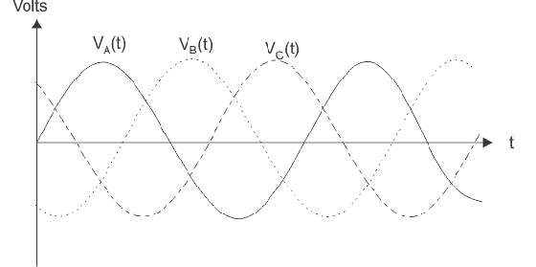

**Why Three Phase is preferred Over Single Phase?**

There are various reasons for this question because there are numbers of advantages over single phase circuit. The three phase system can be used as three single phase line so it can act as three single phase system. The three phase generation and single phase generation is same in the generator except the arrangement of coil in the generator to get 120° phase difference. The [conductor](https://www.electrical4u.com/electrical-conductor/) needed in three phase circuit is 75% that of conductor needed in single phase circuit. And also the instantaneous power in single phase system falls down to zero as in single phase we can see from the sinusoidal curve but in three phase system the net power from all the phases gives a continuous power to the load.

Till now we can say that there are three [voltage source](https://www.electrical4u.com/ideal-dependent-independent-voltage-current-source/) connected together to form a three phase circuit and actually it is inside the generator. The generator is having three voltage sources which are acting together in 120o phase difference. If we can arrange three single phase circuit with 120o phase difference, then it will become a three phase circuit. So 120o phase difference is must otherwise the circuit will not work, the three phase load will not be able to get active and it may also cause damage to the system.  
The size or metal quantity of three phase devices is not having much difference. Now if we consider the transformer, it will be almost same size for both single phase and three phase because [transformer](https://www.electrical4u.com/what-is-transformer-definition-working-principle-of-transformer/) will make only the linkage of [flux](https://www.electrical4u.com/what-is-flux-types-of-flux/). So the three phase system will have higher efficiency compared to single phase because for the same or little difference in mass of transformer, three phase line will be out whereas in single phase it will be only one. And losses will be minimum in three phase circuit. So overall in conclusion the three phase system will have better and higher efficiency compared to the single phase system.  
In three phase circuit, connections can be given in two types:

1. Star connection
2. Delta connection

**Star Connection**

In **star connection**, there is four wire, three wires are phase wire and fourth is neutral which is taken from the star point. Star connection is preferred for long distance [power transmission](https://www.electrical4u.com/electrical-power-transmission-system-and-network/) because it is having the neutral point. In this we need to come to the concept of balanced and unbalanced [current](https://www.electrical4u.com/electric-current-and-theory-of-electricity/) in power system.

When equal current will flow through all the three phases, then it is called as balanced current. And when the current will not be equal in any of the phase, then it is unbalanced current. In this case, during balanced condition there will be no current flowing through the neutral line and hence there is no use of the neutral terminal. But when there will be unbalanced current flowing in the three phase circuit, neutral is having a vital role. It will take the unbalanced current through to the ground and protect the transformer. Unbalanced current affects transformer and it may also cause damage to the transformer and for this star connection is preferred for long distance transmission. The star connection is shown below-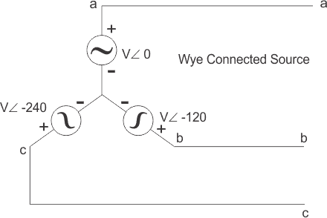In star connection, the line voltage is √3 times of phase voltage. Line voltage is the [voltage](https://www.electrical4u.com/voltage-or-electric-potential-difference/) between two phases in three phase circuit and phase voltage is the voltage between one phase to the neutral line. And the current is same for both line and phase. It is shown as expression below

**Delta Connection**

In **delta connection**, there is three wires alone and no neutral terminal is taken. Normally delta connection is preferred for short distance due to the problem of unbalanced current in the circuit. The figure is shown below for delta connection. In the load station, ground can be used as neutral path if required.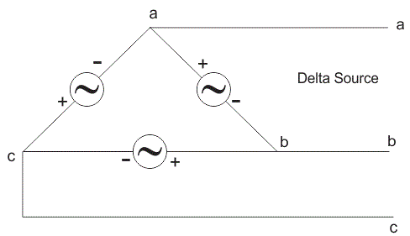

In delta connection, the line voltage is same with that of phase voltage. And the line current is √3 times of phase current. It is shown as expression below,In three phase circuit, star and delta connection can be arranged in four different ways-

1. Star-Star connection
2. Star-Delta connection
3. Delta-Star connection
4. Delta-Delta connection

But the power is independent of the circuit arrangement of the three phase system. The net power in the circuit will be same in both star and delta connection. The power in three phase circuit can be calculated from the equation below,Since, there is three phases, so the multiple of 3 is made in the normal power equation and the PF is [power factor](https://www.electrical4u.com/electrical-power-factor/). Power factor is a very important factor in three phase system and some times due to certain error, it is corrected by using [capacitors](http://www.electrical4u.com/what-is-capacitor-and-what-is-dielectric/).

## Delta - Star Transformation

The replacement of delta or mesh by equivalent star connection is known as **delta - star transformation**. The two connections are equivalent or identical to each other if the impedance is measured between any pair of lines. That means, the value of impedance will be the same if it is measured between any pair of lines irrespective of whether the delta is connected between the lines or its equivalent star is connected between that lines.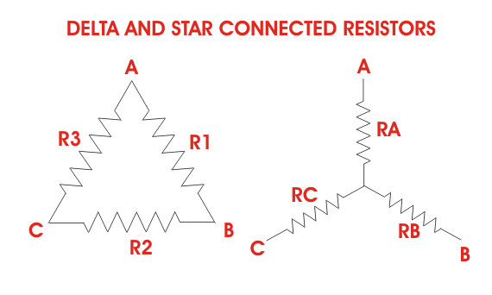Consider a delta system that's three corner points are A, B and C as shown in the figure. [Electrical resistance](https://www.electrical4u.com/electrical-resistance-and-laws-of-resistance/) of the branch between points A and B, B and C and C and A are R1, R2 and R3 respectively.

The [resistance](https://www.electrical4u.com/electrical-resistance-and-laws-of-resistance/) between the points A and B will be,Now, one star system is connected to these points A, B, and C as shown in the figure. Three arms RA, RBand RC of the star system are connected with A, B and C respectively. Now if we measure the resistance value between points A and B, we will get,https://www.electrical4u.com/equations/sdt-01-04-06-14.gifSince the two systems are identical, resistance measured between terminals A and B in both systems must be equal.Similarly, resistance between points B and C being equal in the two systems,And resistance between points C and A being equal in the two systems,Adding equations (I), (II) and (III) we get,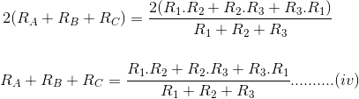Subtracting equations (I), (II) and (III) from equation (IV) we get,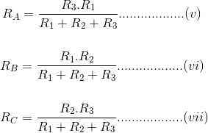The relation of delta - star transformation can be expressed as follows.  
The equivalent star resistance connected to a given terminal, is equal to the product of the two delta resistances connected to the same terminal divided by the sum of the delta connected resistances.  
If the delta connected system has same resistance R at its three sides then equivalent star resistance r will be,

## Star - Delta Transformation

For **star - delta transformation** we just multiply equations (v), (VI) and (VI), (VII) and (VII), (V) that is by doing (v) × (VI) + (VI) × (VII) + (VII) × (V) we get,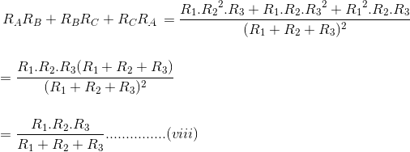Now dividing equation (VIII) by equations (V), (VI) and equations (VII) separately we get,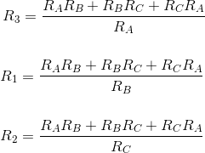

# Relationship of Line and Phase Voltages and Currents in a Star Connected System

[**« Previous**](http://electrical4u.com/vector-algebra-vector-diagram/)

[**Next »**](http://electrical4u.com/vector-diagram-three-phase-vector-diagram/)

To derive the **relations between line and phase currents and voltages of a star connected system**, we have first to draw a balanced star connected system.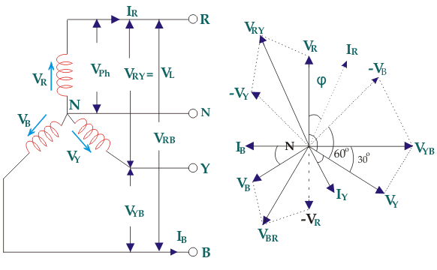Suppose due to load impedance the current lags the applied voltage in each phase of the system by an angle ϕ. As we have considered that the system is perfectly balanced, the magnitude of current and voltage of each phase is the same. Let us say, the magnitude of the voltage across the red phase i.e. magnitude of the [voltage](https://www.electrical4u.com/voltage-or-electric-potential-difference/) between neutral point (N) and red phase terminal (R) is VR.

Similarly, the magnitude of the voltage across yellow phase is VY and the magnitude of the voltage across blue phase is VB. In the balanced star system, magnitude of phase voltage in each phase is Vph.  
∴ VR = VY = VB = Vph

We know in the star connection, line current is same as phase current. The magnitude of this [current](https://www.electrical4u.com/electric-current-and-theory-of-electricity/) is same in all three phases and say it is IL.  
∴ IR = IY = IB = IL, Where, IR is line current of R phase, IY is line current of Y phase and IB is line current of B phase. Again, phase current, Iph of each phase is same as line current IL in star connected system.  
∴ IR = IY = IB = IL = Iph.

Now, let us say, the voltage across R and Y terminal of the star connected circuit is VRY.  
The voltage across Y and B terminal of the star connected circuit is VYB The voltage across B and R terminal of the star connected circuit is VBR.  
From the diagram, it is found that  
VRY =VR (−VY)  
Similarly, VYB =VY +(−VB)  
And, VBR =VB +(−VR)  
Now, as angle between VR and VY is 120o(electrical), the angle between VR and – VY is 180o– 120o= 60o(electrical).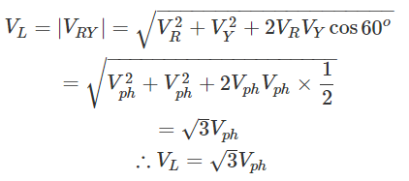

Thus, for the star-connected system line voltage = √3 × phase voltage.  
Line current = Phase current  
As, the angle between voltage and current per phase is φ, the electric power per phase ishttps://www.electrical4u.com/images/september16/1473904100.PNG

So the total power of[three phase system](https://www.electrical4u.com/advantages-of-three-phase-system-over-single-phase-system/)ihttps://www.electrical4u.com/images/september16/1473904264.PNG

Presently 3-ø AC system is very popular and being used worldwide for [power generation](https://www.electrical4u.com/electric-power-generation/), [power transmission](https://www.electrical4u.com/electrical-power-transmission-system-and-network/), distribution and for [electric motors](https://www.electrical4u.com/electrical-motor-types-classification-and-history-of-motor/).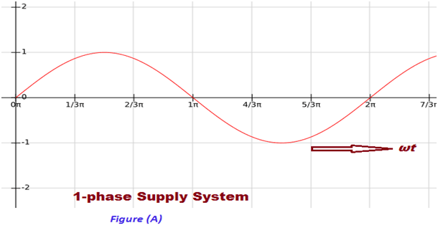

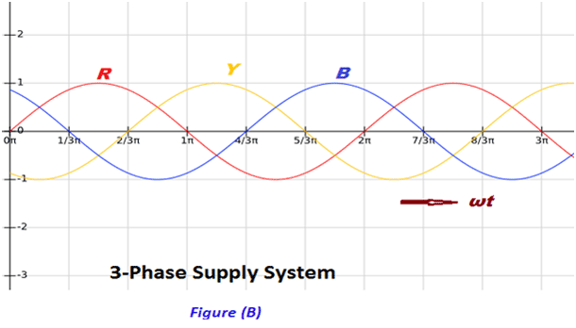[Three phase system](https://www.electrical4u.com/three-phase-circuit-star-and-delta-system/) has the following advantages as compare to single phase system:

1. Power to weight ratio of 3-ø [alternator](https://www.electrical4u.com/alternator-or-synchronous-generator/) is high as compared to 1-ø alternator. That means for generation for same amount of [Electric Power](https://www.electrical4u.com/electric-power-single-and-three-phase/), the size of 3-ø alternator is small as compare to 1-ø alternator. Hence, the overall cost of alternator is reduced for generation of same amount of power. Moreover, due to reduction in weight, transportation and installation of alternator become convenient and less space is required to accommodate the alternator in power houses.
2. For [electric power transmission](https://www.electrical4u.com/electrical-power-transmission-system-and-network/) and distribution of same amount of power, the requirement of [conductor](https://www.electrical4u.com/electrical-conductor/) material is less in 3-ø system as compare to 1-ø system. Hence, the 3-ø transmission and distribution system is economical as compare 1-ø system.
3. Let us consider the power produced by single phase supply and 3-phase supply at unity [power factor](https://www.electrical4u.com/electrical-power-factor/). Wave form of power produce due 1-phase supply at unity power factor is shown in figure (C) and Wave form of power produced due to 3-phase supply is shown in figure (D) below.

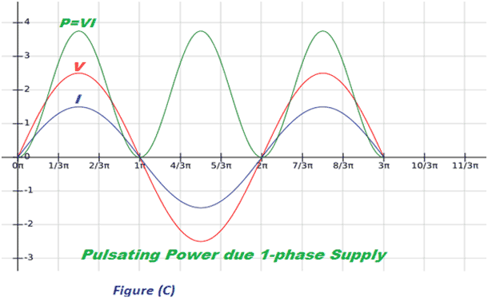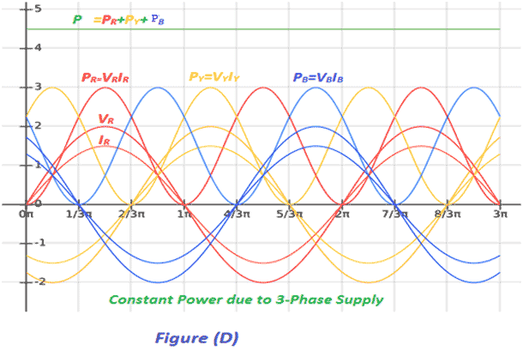

1. From power wave forms shown in figure (C) and (D) above it is clear that in 3-phase system, the instantaneous power is always constant over the cycle results in smooth and vibration free operation of machine. Whereas in 1-ø system the instantaneous power is pulsating hence change over the cycle, which leads to vibrations in machines.
2. Power to weight ratio of [three phase induction motor](https://www.electrical4u.com/working-principle-of-three-phase-induction-motor/) is high as compare to [single phase induction motor](https://www.electrical4u.com/single-phase-induction-motor/). Means for same amount of Mechanical Power, the size of three phase induction motor is small as compare to single phase induction motor. Hence, the overall cost of [induction motor](https://www.electrical4u.com/induction-motor-types-of-induction-motor/) is reduced. Moreover, due to reduction in weight, transportation and installation of induction motor become convenient and less space is required to accommodate the induction motor.
3. 3-phase induction motor is self-started as the magnetic flux produced by 3-phase supply is rotating in nature with constant magnitude. Whereas 1-ø induction motor is not self-started as the [magnetic flux](https://www.electrical4u.com/what-is-magnetic-field/)produced by 1-ø supply is pulsating in nature. Hence, we have to make some arrangement to make the 1-ø induction motor self-started which further increases the cost of 1-ø induction motor.
4. 3-phase motor is having better power factor and efficiency as compare to 1-ø motor.
5. Power to weight ratio of [3-phase transformer](https://www.electrical4u.com/single-three-phase-transformer-vs-bank-of-three-single-phase-transformers/) is high as compare to 1-ø transformer. Means for same amount of Electric Power, the size of 3-phase transformer is small as compared to 1-ø transformer. Hence, the overall cost of transformer is reduced. Moreover, due to reduction in weight, transportation and [installation of transformer](https://www.electrical4u.com/installation-of-power-transformer/) become convenient and less space is required to accommodate the transformer.
6. If fault occurs in any winding of 3-phase transformer, the rest of two winding can be used in open delta to serve the 3-phase load which is not possible in 1-ø [transformer](https://www.electrical4u.com/what-is-transformer-definition-working-principle-of-transformer/). This ability of 3-phase transformer further increases the reliability of 3-phase transformer.
7. A 3-phase system can be used to feed a 1-ø load, whereas vice-versa is not possible.
8. DC rectified from 3-phase supply is having the ripple factor 4% and DC rectified from 1-ø supply is having the ripple factor 48.2%. Mean DC rectified from 3-ø supply contains less ripples as compare to DC rectified from 1-ø supply. Hence the requirement of filter is reduced for DC rectified from 3-phase supply. Which reduce the overall cost of converter.

From above it is clear the 3-phase system is more economical, efficient, reliable and convenient as compared to 1-ø system.